Joey on a gameshow 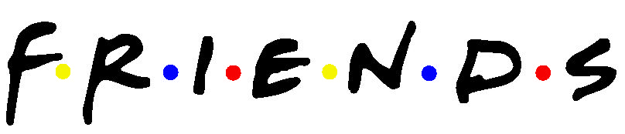
Watch the fragment of Joey on a gameshow and answer these questions. If you think that an answer is correct, you can put an X in front of the correct answer.
1. What is the name of the show?  - Eiffel Tower  - Pyramid  - Statue of Liberty  2. Which is the first category the man(Jean) chooses?  - You crossed the line  - Baby on bjork  - What's in the refrigerator  3. Why did Joey fail to explain supermarket correctly?  - He didn't know the meaning of supermarket.  - He explained it too difficultly.  - He said the word supermarket.  4. What are things that don't have lines?  - Wallet  - Supermarket  - Notebook  5. You put this in your coffee.  - Cream  - Ghost  - Spoon  6. What are the common characteristics of paper, snow and ghost?  - They are black.  - They are white.  - They smell bad.  7. You put this on a hamburger.  - Water  - Ghost  - Ketchup | 8. Before the break the MC says "Don't go ......"  - up  - away  - down  9. What category does joint session, legislative, go into?  - Things associated with the United States Congress.  - Things associated with the Canadian Congress.  - Things associated with school.  10. What does Joey say when he doesn't know the word?  - Next!  - Over!  - Pass!  11. Who are the two people that get into the winner's circle?  - Jack and Jill  - Jean and Joey  - Jean and Jill  12. What are oak, maple and elm?  - Types of fruits  - Types of trees  - Types of transportation  13. What are matches, candles, torches and bonfire?  - Things that sink  - Things that melt  - Things that burn  14. What proverb can be used for this situation?  - The grass is greener on the other side of the fence.  - A blind man may sometimes catch the hare.  - Birds of a feather flock together.

